JKUAT and NWU Forge Strategic Alliance as WHO-Designated Partners to Transform Africa’s Health Workforce
Department of Statistics and Actuarial Sciences (STACS), Jomo Kenyatta University of Agriculture and Technology
In a landmark achievement for African academia and public health, Jomo Kenyatta University of Agriculture and Technology (JKUAT), together with the Centre for Health Professions Education (CHPE) at North-West University (NWU), has been selected as a winner in the World Health Organization (WHO) AFRO Network of Partner Institutions (NPI) for Health Systems. This prestigious designation establishes a powerful East–Southern African partnership dedicated to addressing one of the continent’s most pressing challenges: building a resilient, competent, and sustainable health workforce.
A Two-Pronged Strategy for Workforce Transformation
The consortium’s winning proposal under Pillar 2: Enhancing Health Workforce Development for Sexual and Reproductive Health and Rights (SRHR) outlines a complementary strategy:
- NWU’s CHPE will lead the development of continental education and training standards, ensuring health professionals are uniformly and excellently prepared.
- JKUAT’s STACS Department will spearhead operational research, generating critical data and predictive models to inform policy on workforce retention, strategic deployment, and productivity.
The WHO selection committee, faced with an overwhelming number of high-quality applications, commended the submission’s exceptional merit, noting: “This recommendation reflects the substantial merit of the submission, and we are encouraged by your commitment to advancing the strengthening of health systems in the region.” The project has been recommended for a significant grant award, pending final contractual processes.
Bridging the Gap: From Research to Health System Solutions
At the heart of JKUAT’s role is a commitment to applied, impact-driven science. The STACS Department has established itself as a continental leader in quantitative health systems analysis and predictive modelling for human resources for health (HRH).
Led by Dr. Joseph K. Mung’atu (Principal Investigator), the project exemplifies STACS’s mission: bridging the gap between academic research and practical health system solutions.
“Our core expertise is in turning complex health workforce data into actionable intelligence for decision-makers,” said Dr. Mung’atu. “We are not just studying problems; we are building the tools to solve them. This WHO project will allow us to produce definitive, region-wide information on HRH—pinpointing exactly where investments in retention, incentives, and deployment will yield the highest return in lives saved, particularly in the critical domain of Sexual and Reproductive Health.”
Through advanced statistical modelling, ROI analyses, and scenario-based forecasting, STACS will provide ministries of health with evidence-based answers to pressing questions:
- How can skilled health workforce be retained in rural clinics?
- What is the optimal mix of health workers for SRHR facilities?
- How does investment in continuous professional development translate into improved maternal health outcomes?
The JKUAT “Solutions Team”
The strength of JKUAT’s bid lies in its multidisciplinary team of experts, each contributing vital expertise to address the multifaceted HRH challenge:

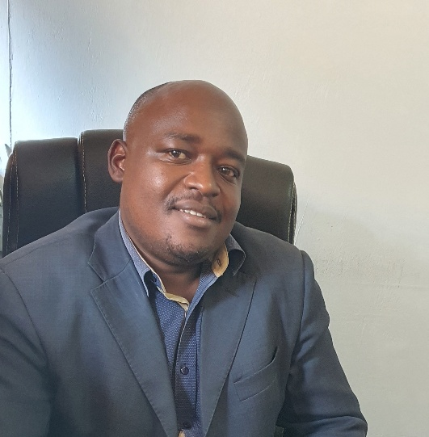
- Dr. Joseph K. Mung’atu (Principal Investigator): Senior statistician and modeller, providing scientific leadership and ensuring policy relevance.
- Prof. Anthony Waititu: Dean, School of Mathematical and Physical Sciences, offering strategic oversight and institutional commitment.
- Dr. Charity Wamwea: Chair, STACS and Co-Principal Investigator, ensuring institutional alignment and resource mobilization.
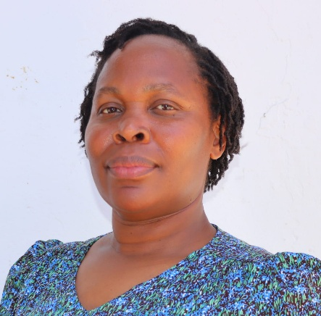
- Dr. Jane A. Akinyi: Statistician and health researcher, specializing in SRHR metrics and gender-focused outcomes.

- Dr. Winnie Chacha: Financial modeller, leading ROI analyses to guide national budgeting.

- Dr. Ann Omamo: Human resource management specialist, ensuring models reflect real-world workforce dynamics.

- Dr. Matabel Odin: Expert in financial mathematics, supporting economic valuation and risk analysis.

- Mr. Henry Kissinger Ochieng Statistician, driving robust data management and translation of results into actionable insights.

- Ms. Caro W. Mugo: Statistician, driving robust data management and translation of results into actionable insights.

Toward African Health Sovereignty
This partnership represents more than a project—it signals a paradigm shift toward African-led, evidence-based health system sovereignty. By combining NWU’s pedagogical leadership with JKUAT’s data-science expertise, the consortium is building a self-reliant model for continuous health workforce improvement.
“This selection by WHO AFRO is a powerful validation of JKUAT’s strategic direction to be a solutions-oriented university,” said Prof. Anthony Waititu. “We are moving beyond publishing papers to actively shaping the future of healthcare in Africa. This partnership with NWU demonstrates that African institutions now possess the advanced, home-grown expertise to diagnose our own challenges and prescribe the solutions. We are building the analytical backbone for the next generation of Africa’s health workforce.”
The project positions JKUAT’s STACS Department as an indispensable partner for health ministries and international agencies, charting a path toward future designation as a WHO Collaborating Centre for Health Workforce Analytics and Planning.

About STACS at JKUAT
The Department of Statistics and Actuarial Sciences (STACS) is a hub of innovation, specializing in actuarial science, financial engineering, and statistical modelling for health, finance, and industry. Learn more about our mission to solve complex challenges through data at STACS Department Page.
Submitted: January 2026

